Background
This project originated two and a half years ago as a follow-on to an earlier effort conducted during the COVID-19 pandemic. The initial project produced a product that mapped soft power investments by hard target countries toward Middle Eastern nations. While the outputs provided analysts with valuable insights into the reach of foreign influence activities, the process relied heavily on manual review and annotation. Analysts were responsible for categorizing articles, identifying the initiating and recipient countries, and labeling the relevant domains of soft power influence.
This manual approach quickly revealed opportunities for automation. The repetitive and structured nature of categorization, country identification, and schema application made these tasks well-suited for natural language processing (NLP) techniques.
Initially, the plan was to employ traditional NLP methods and supervised training pipelines. The approach envisioned the development of a custom dataset through human annotation, followed by training a classification model to recognize soft power engagements according to a predefined schema. While this strategy was sound in principle, it carried significant costs and risks. The annotation process would have required thousands of labeled examples across multiple categories and subcategories to ensure adequate coverage, while the resulting model would likely need frequent retraining to adapt to evolving analytic requirements.
At the time, ChatGPT-3.5 represented the state of the art in generative modeling. Early testing demonstrated strong potential but also revealed significant inconsistencies in outputs, along with high token costs that made scaling prohibitively expensive. This forced a critical decision point: whether to invest the project’s limited resources in building annotated datasets and custom classifiers, or to accept the token costs and bet on future improvements in generative model performance.
Initial prompt engineering experiments proved decisive. With carefully structured instructions, ChatGPT-3.5 began closing the performance gap on fundamental tasks such as category classification and entity extraction. These early gains suggested that generative AI could outperform traditional NLP pipelines over the long term, particularly as newer models were released. On this basis, the project determined that investing in the GAI approach was the most viable long-term strategy, balancing near-term performance with adaptability and cost savings over time.
The release of GPT-4 validated this decision. Its dramatic increase in accuracy, consistency, and ability to follow complex prompt structures demonstrated that generative AI could meet the project’s technical requirements far more effectively than traditional approaches. However, challenges remained in the form of token costs and the scaling of inference across large corpora. These constraints required ongoing experimentation with workflow design, model selection, and potential fallback strategies such as student-model distillation to ensure sustainability.
To operationalize the risk framework, each identified challenge was assessed in terms of its likelihood and potential impact on the project. Table X summarizes the core risks, their assessed likelihood and impact, and the mitigation measures incorporated into the workflow. These measures ensured that the adoption of Generative AI remained aligned with mission requirements while minimizing exposure to technical, organizational, and governance risks.

Risk Management Matrix
Risk Area | Description | Likelihood | Impact | Mitigation Measures
Cost & Scalability | High token costs for GPT-4 and similar models limit scalability across large corpora. | High | High | Limit GAI to high-value tasks; batch/cluster inputs; evaluate open-source models (e.g., LLaMA); explore student-model distillation.
Black-Box & Hallucination | GAI outputs may include fabricated or misattributed content that appears authoritative. | Medium | High | Enforce JSON-constrained outputs; apply post-processing validation; institute SME review; track provenance to article IDs.
Evaluation & Ground Truth | No comprehensive dataset exists for soft power; human annotators diverge in interpretations. | High | Medium | Combine external and internally generated samples; overlap annotations for variance checks; SME adjudication.
Cultural & Governance | Institutions lack clear policies on GAI use, evaluation standards, and governance of outputs. | Medium | High | Focus adoption on factual tasks; prohibit unsupervised propagation; document risk procedures; enforce provenance chain.

1. Proof-of-Concept Testing
The Global Chinese Development & Finance (GCDF) dataset provided the first benchmark for evaluation. Although the dataset was limited—containing only positive samples and summarized descriptions rather than full articles—it offered a controlled testbed for measuring whether GAI models could correctly identify soft power activities and apply structured labeling schemas.

2. Model Comparisons
Multiple models were tested, including GPT-3.5, GPT-4, LLaMA-2 (70B and 8B), LLaMA-3 (8B and 70B), and Facebook’s BART Large MNLI model for zero-shot classification. Each was evaluated on the ability to:
- Identify whether a text described a soft power event (salience).
- Classify events into categories and subcategories.
- Extract initiating and recipient countries.
- Maintain output consistency with structured JSON prompts.

3. Performance Results
- Salience Detection:
  - GPT-4 demonstrated the most conservative and reliable salience judgments, flagging 20–30% of articles as relevant.
  - GPT-3.5 tended toward over-inclusion, flagging ~56%.
  - Open-source LLaMA models showed variable performance but trended closer to GPT-3.5 in permissiveness.
  - Zero-shot baselines (MNLI) were inconsistent and often misapplied categories.
- Categorization and Sub-Categorization:
  - GPT-4 achieved an F1 score of 0.865 with high precision (0.94) in mapping texts to soft power categories.
  - GPT-3.5 and LLaMA models performed moderately well but were more sensitive to prompt errors and less consistent with output formatting.
  - GPT-4 successfully applied detailed schemas, including sector-specific subcategories, without retraining.
- Entity Extraction:
  - All models performed near-perfectly in identifying initiating and recipient countries, with errors occurring primarily when source text used regional rather than country-level references.
  - Monetary values and project names were extracted with high accuracy when explicitly present in text.
- Consistency and Format Compliance:
  - GPT-4 consistently adhered to structured output formats (JSON), critical for downstream post-processing.
  - GPT-3.5 and LLaMA models occasionally drifted, omitting required fields or introducing narrative text despite prompt constraints.

4. Human vs Model Labeling
Two labeling exercises were conducted to test alignment between human annotators and GAI outputs:
- Round 1: Three annotators collaboratively labeled 100 documents. Results diverged significantly from model labels, with humans adopting a narrower interpretation of soft power. Analysts later reviewing disagreements often sided with the models, suggesting annotators under-flagged relevant cases.
- Round 2: A separate set of 200 documents was labeled independently by three annotators. Divergence persisted, confirming variability in human interpretation. Despite this, models captured nearly 100% of human-identified true positives, with disagreements concentrated in borderline or “grey area” cases.

5. Conclusions
The evaluation confirmed that GAI models, particularly GPT-4, were capable of performing soft power classification and extraction tasks at scale. Key findings included:
- LLMs could reliably apply custom schemas without retraining.
- GPT-4 outperformed other models in precision, consistency, and adherence to formatting.
- Human annotators exhibited high variance in labeling, complicating efforts to establish a definitive ground truth.
- Analysts often judged model outputs as more accurate than first-pass human labels, underscoring the value of iterative human-in-the-loop evaluation rather than static benchmarks.
Overall, the evaluation demonstrated that GAI could replace traditional supervised NLP pipelines for the project’s core tasks, provided that costs, black-box risks, and governance concerns were actively managed through risk mitigation strategies.

Prompt Design
In parallel with evaluating model performance, the project tested the impact of prompt design on accuracy, consistency, and task coverage. Given that GAI performance is highly sensitive to input structure, iterative testing was conducted to determine whether verbose, heavily-instructed prompts or concise, minimalist prompts yielded more reliable outputs for soft power analysis.

1. Verbose vs. Concise Prompts
- Concise prompts tended to overgeneralize, particularly in salience detection. For example, GPT-3.5 frequently labeled 50–60% of articles as soft power relevant when given short instructions, suggesting that minimal guidance produced an overly generous interpretation of the concept.
- Verbose prompts, which included detailed definitions of soft power, explicit schema rules, and examples of acceptable JSON outputs, significantly reduced false positives. GPT-4 in particular responded well to structured, multi-step instructions, demonstrating salience rates more in line with analyst expectations (20–30%).
- Open-source models such as LLaMA were especially sensitive to prompt specificity: small formatting errors (missing quotes, inconsistent labels) often degraded output consistency.

2. Structured Output Enforcement
Prompts that constrained models to return JSON outputs proved critical for pipeline integration. GPT-4 adhered reliably to this structure, while GPT-3.5 and LLaMA variants occasionally drifted, omitting fields or introducing explanatory text. Including an explicit “ONLY output JSON” instruction and providing an example template greatly improved compliance across all models.

3. Expanded Task Capabilities
Beyond salience and categorization, prompt engineering enabled the models to take on additional tasks that were not part of the original project scope but proved both viable and valuable:
- Summarization: Producing distilled text that retained only soft power–relevant content allowed for reduced context sizes and more efficient downstream processing.
- Geolocation: By prompting models to infer the nearest city or country latitude/longitude when explicit coordinates were missing, events could still be mapped consistently in geospatial dashboards.
- Monetary Commitments: Models reliably extracted referenced funding amounts when present, normalizing them into USD for comparability.
- Event Naming: Generative prompts were used to create short, descriptive titles (e.g., “China–Egypt Suez Canal Zone Investment Agreement”) that could serve as identifiers in event-level tracking.

4. Evolution with Newer Models
As newer models such as GPT-4o became available, instruction-following proved to be less of a bottleneck. Given a well-structured text sample, these models could execute nearly any traditional NLP task—classification, entity extraction, summarization, clustering—without extensive prompting. This shifted the primary challenge away from writing increasingly detailed instructions and toward structuring the context itself:
- Context Window Management: Efficiently chunking and distilling large article corpora to fit within model input limits.
- Information Density: Ensuring that prompts only included soft power–relevant content to maximize signal within constrained token budgets.
- Schema Alignment: Designing context presentations that emphasized the relationships among categories, countries, and events so that outputs could be consistently aggregated downstream.
In effect, the role of prompt design evolved. With earlier models (GPT-3.5, GPT-4), prompt specificity was the deciding factor for accuracy and consistency. With GPT-4o and beyond, context engineering—how information was organized, distilled, and sequenced—became the decisive variable for system performance.

Executive Summary
The project aims to identify and categorize articles discussing soft power activities conducted by hard target countries towards Middle Eastern nations. Initially, a custom supervised topic model was planned, but advancements in generative AI (GAI) models offered a more efficient solution. Evaluations showed GAI models not only excelled in categorizing articles by soft power topics but also performed Named Entity Recognition (NER) tasks effectively. The decreasing costs of GAI made it the most timely and cost-effective approach for the project. The blackbox nature of GAI inference poses an ongoing risk that this project will attempt to mitigate through periodic evaluations of the GAI outputs to monitor performance and will explore training a student model using GAI outputs as a contingency.
With the more advanced capabilities offered by GAI, this project expanded the scope of inference through innovative prompt engineering, to not only categorize, but identify initiating and recipient countries of soft power interactions, specific project details to include monetary value, and geocoordinates.
Workflow Steps:
- Salience run. NE_AUTO holdings are queried and results are run through GPT 3.5 turbo on ingest to detect articles that are relevant to the soft power project. Alternatively, for acquiring historic records prior to DS&R ingest, NE_AUTO is queried in and the same salient and extraction prompts are run in 1toN.

- Extraction run. Salient articles are then run through an extraction prompt using GPT 4o which categorizes the articles according to a soft power labelling schema the team developed. The prompt also creates a distilled version of the article containing soft power relevant content. Initiating and recipient countries are identified, and the location (latitude-longitude) are determined. These details serve as the foundational data in the later steps.

- Unique event identification. After extraction, we next identify unique soft power events mentioned across the corpus. Processing the entirety of distilled soft power relevant articles will exceed both the context and output limits of current GAI models (128K token input, 10K token output). Using the corpus’s distilled text, we cluster the corpus by cosine similarity into chunks of 50 articles. Each chunk is run through GAI and outputs a simple json structure {‘project-name’: <event1>, [<list of article ids discussing event1> ],’project-summary’: <summary text>…}. The resulting objects are given an ‘event-id’ (EID) consisting of consolidated atom-ids and summary of the relevant distilled texts.

- Event aggregation. To account for duplicative events that may fall into separate 50 article chunks, another round of clustering and GAI aggregation is run on the event objects themselves, these consolidated event objects are assigned a soft power id (SPID). These SPID objects are run through GAI, with all underlying distilled texts, to produce an overarching event-name and event-summary.

- Event tracking. The next effort focused on flagging and incorporating updates into SPIDs over time. Processes 1-3 are repeated on the next week’s batch of soft power data, but instead of conducting a second round of clustering and aggregation, these event objects are compared to each of the previously identified SPID objects to determine if they are new events or updates. Updated SPID’s are run through GAI to incorporate the new information. New events are run through step 4 and assigned an SPID.

- Findings by Country. SPIDs are filtered by country and run through GAI to build a weekly summary of soft power events by country. Findings for each summary use the distilled text in underlying ATOM articles as a reference, and sources its findings with relevant ids to build hyperlinks that allow analysts to lookup the original text.

- Visualization. In tableau, SPID-EID-ATOM ID mapping allows for a dynamic manipulation of soft power data from the country level down to the individual article.

- SME Review. In my mind, this is where the programmatic processes shift over to human intervention and preparation of the data. The SPIDs will encompass the soft power database which the analysts can do a number of actions with. They can flag high priority SPIDs for more detailed tracking, they can split up SPIDs that are over consolidated or combine multiple SPIDs which should be tracked as a single event.
Outputs:
- SoftPower Database: SPIDs, with categories, countries, name, location, and event summary.
- SPID-EID, EID-AtomID mappings.
- Weekly/Monthly Soft Power highlights by Country (via html, word, or tableau dashboard)
- SoftPower Dashboard: Event metrics and trends by country.
Prompts:
- Salience:
  - You are an international relations expert on the use of Soft Power influence from one country towards another country. Soft power is the ability of a country to shape the preferences and behaviors of other nations through appeal and attraction rather than coercion or payment. This influence is exerted through cultural diplomacy, values, policies, political ideals, educational exchanges, and media, fostering goodwill and fostering mutual understanding. Soft power aims to build positive relationships and international cooperation by enhancing a country's reputation and credibility globally.

Please execute the following steps,

1. Assess whether the given text is an example of the use of soft power influence as defined above.

2. In 200 words or less, explain why the text was determined to be either an example of a soft power engagement or not an example of a soft power engagement.

3. Output the result in json, for example {"salience-justification": "X country is attempting to influence Y country's stance towards it via investments in Y country's education system.", "salience": true } or {"salience-justification": "X country's actions towards Y country is not an example of soft power diplomacy.", "salience": false}

- Extraction
  - You are an expert in tracking and identifying inter-country 'soft power' engagements, where one country through economic, social, cultural, or political means, fosters influence over another country.
Please execute the following steps and output the results using the provided json template.

1. Determine if the focus of the following text is a soft power-related event or influence activity of one country towards another. Ensure that the context in which soft power is discussed is significant and substantial, not merely a passing reference. Avoid flagging articles that only broadly mention a soft power relevant event without focusing on specific events or initiatives. Exclude articles that primarily focus on unrelated topics with only a tangential mention of a soft power relevant event.

2. If it is, in 200 words or less, explain why the text was determined to be either an example of soft power or not an example of soft power.

3. If the text is an example of soft power, identify the nature of the activity and output one or more of the following categories, if more than one topic is relevant, separate them by semicolons.

1) "Economic": Characterized by the use of economic tools and policies to influence other countries' behaviors and attitudes. Articles should be classified as Economic only if a specific deal, exchange, or market is referenced, otherwise general non-specific discussions of economic ties should be binned under "Diplomacy".

2) "Social": Characterized by the use of cultural, ideological, and social tools to influence other countries' behaviors and attitudes, fostering admiration, respect, and alignment with a country's values and way of life. This category includes financial and material donations or aid.

3) “Diplomacy": Characterized by the use of diplomatic channels, negotiations, and international relations to shape the preferences, attitudes, and behaviors of other nations in a way that aligns with a country’s interests.

4) “Military": Characterized by the strategic use of military resources and capabilities to build goodwill, foster international cooperation, and project a positive image without engaging in direct military conflict or coercion.

4. In 200 words or less, explain why the specific category or categories was selected.

5. Next, from the provided text, determine which of the following subcategories aligns best to the context of the provided text as a whole. Each category MUST have a sub-category.

If the overall category is "Economic", determine which of the following sub-categories aligns best to the context of the text:
A. Trade
B. Food
C. Finance
D. Technology
E. Transportation
F. Tourism
G. Industrial
H. Raw Materials
I. Infrastructure
J. If the economic activity doesn't fall within any of the above categories, return "Other-" with a one word label of the activity.

If the overall category is "Social", determine which of the following sub-categories aligns best to the context of the text:
A. Cultural
B. Education
C. Healthcare
D. Housing
E. Media
F. Politics
G. Religious
H. Aid/Donation
I. If the social activity doesn't fit any of the above categories, return "Other-"with a one word label of the activity.

If the nature of the activity is "Diplomacy", determine which of the following diplomacy subcategories the activity falls under:
A. Multilateral/Bilateral Commitments
B. International Negotiations
C. Conflict Resolution
D. Global Governance Participation
E. Diaspora Engagement
F. If the Diplomacy activity doesn't fit any of the above categories, return "Other-"with a one word label of the activity.
If the overall category is "Military", determine which of the following sub-categories aligns best to the context of the text:
A. Sales
B. Joint Exercises
C. Training
D. Conferences
E. If the military activity doesn't fall under any of these, return "Other-" with a one word label of the activity.

6. Determine the country initiating the softpower exchange from the provided text. If more than one initiating country is identified, separate them with semicolons.

7. Determine the recipient country of the softpower exchange from the provided text. If more than one recipient country is identified, separate them with semicolons. The initiating and recipient country should never be the same.

8. Identify specific projects, conferences, or initiative names, for example, "Maputo Central Hospital," "National Theater Renovation Project," or "Tengchong-Myitkyina Road Construction Project;Opium Alternative Planting Project." If more than one is found, separate them with semicolons.

9. Provide the approximate latitude and longitude of the activity, if unavailable, provide the Latitude and longitude of the nearest locality or recipient country.

10. Provide the nearest locality of the event, for example "Tehran, Iran".

11. Identify and output the monetary commitment of the activity of commitment in USD, for example "$100,000,000."

12. Distill the content of the text to only the context relevant to a soft power exchange. All locations, persons, projects, and monetary values should remain in the distilled output.

13. Produce an event name that capture the soft power interaction and key actors or entities involved.

14. Output the result in json, for example {"salience-justification": "Reason the text is an example of soft power.", "salience-bool": <BOOLEAN>, "category": "<CATEGORY TEXT>", "category-justification": "<JUSTIFICATION TEXT>", "subcategory": "<SUBCATEGORY TEXT>", "initiating-country": "<COUNTRY TEXT>", "recipient-country": "<COUNTRY TEXT>", "projects": "<REFERENCED PROJECTS LIST>", "LAT_LONG": "<LATITUDE AND LONGITUDE>","location": "<LOCATION TEXT>", "monetary-commitment": "<REFERENCED MONETARY VALUES>", "distilled-text": "<DISTILLED TEXT>","event-name": "<EVENT NAME>"}, {"salience-justification": "<JUSTIFICATION TEXT>", "salience-bool": false}.

IMPORTANT: ONLY output the json. ONLY use the json format. The output values should ONLY be in English.
- Event Consolidation
Your task is to analyze a JSON-formatted list and create a new json list of unique events.
To create the unique event list, follow these steps:

1. Analyze the "distilled-text" field under each "ATOM ID".
2. Determine the unique events referenced
3. Create an event name for each unique event.
4. Combine the ATOM ID's of items referencing the same unique event.
5. Create an “event-summary” from the combined "distilled-text" content for each unique event.
5. VERIFY that all of the ATOM ID's in the original JSON are present in the unique event list.

Here is an example of what is being asked.

Example INPUT:

[{"ATOM ID": "07146950-61b0-4865-8c1c-b7f3e4936cf2",
"distilled-text": "<DISTILLED TEXT>",
{"ATOM ID": "092ea7f8-becc-4ff4-8d6b-3c7c1353983d",
"distilled-text": "<DISTILLED TEXT>",
{"ATOM ID": "11dd2b87-fc4c-4996-93dd-6d07cc2336dd",
"distilled-text": "<DISTILLED TEXT>"}]

The example input contains 3 references, after reviewing the "distilled-text" content, it is determined that ATOM ID's "092ea7f8-becc-4ff4-8d6b-3c7c1353983d" and "11dd2b87-fc4c-4996-93dd-6d07cc2336dd" are both referencing the same unique event and "07146950-61b0-4865-8c1c-b7f3e4936cf2" is its own unique event . Therefore the output should look as follows:

[{"event-name": "Academic and Technological Exchange", "atom-ids": ["092ea7f8-becc-4ff4-8d6b-3c7c1353983d","11dd2b87-fc4c-4996-93dd-6d07cc2336dd"],"event-summary": "<EVENT SUMMARY OUTPUT>"},
{"event-name": "BRICS Membership", "atom-ids": ["07146950-61b0-4865-8c1c-b7f3e4936cf2"], "event-summary":"<EVENT SUMMARY OUTPUT>"}]

Note how all ATOM ID's are present in the output. It is very important that all ATOM ID's from the input are represented in the output.

IMPORTANT: Translate all non-English text into English. ONLY OUTPUT THE JSON RESULT. ONLY USE THE JSON FORMAT

- Unique Event:
  - Your task is to analyze a JSON-formatted list and create a new json list of unique events.
To create the unique event list, follow these steps:

1. Analyze the "event-summary" and "event-name" fields under each "event-id". An event-id is an alphanumeric unique identifier, for example: "eid_4c37b1816b56462c8cf742430d227747".
2. Determine the unique events, conferences, projects, or initiatives referenced across the corpus.
3. Combine the event-id's of items referencing the same unique event, conference, project, or initiative.
4. Create a name for the consolidated event, conference, project, or initiative that is descriptive and not overly vague. Combine the eid's of items referencing the same unique event, conference, project, or initiative.
5. VERIFY that all of the eid's in the original JSON are present in the new consolidated event, conference, project, or initiative list.

Here is an example of what is being asked.
Example INPUT:

[{'event-name': "<EVENT NAME TEXT>",
'event-summary': "<EVENT SUMMARY TEXT>",
'event-id': "eid_1258c7c8e97a430bbdfc2df535eadbf8"},
{'event-name': "<EVENT NAME TEXT>",
'event-summary': "<EVENT SUMMARY TEXT>",
'event-id': "eid_0969ef41bd534bc58833bb4a9d380e29"},
{'event-name': "<EVENT NAME TEXT>",
'event-summary': "<EVENT SUMMARY TEXT>",
'event-id': "eid_4c37b1816b56462c8cf742430d227747"}]

The example input contains 3 references, after reviewing the "event-summary" and "event-name" fields, it is determined that event-ids "eid_1258c7c8e97a430bbdfc2df535eadbf8" and "eid_0969ef41bd534bc58833bb4a9d380e29" are both referencing the same unique event and "eid_4c37b1816b56462c8cf742430d227747" is its own unique event . Therefore the output should look as follows:

[{"event-name": "<EVENT NAME>", "event-ids": ["eid_1258c7c8e97a430bbdfc2df535eadbf8","eid_0969ef41bd534bc58833bb4a9d380e29"]},
{"event-name": "<EVENT NAME>", "event-ids": ["eid_4c37b1816b56462c8cf742430d227747"]}]

Note how all eid's are present in the output. It is very important that all eid's from the input are represented in the output.

IMPORTANT: Translate all non-English text into English. ONLY OUTPUT THE JSON RESULT. ONLY USE THE JSON FORMAT

- Event Update:
  - You are an expert analyst and international relations expert on issues relating to soft power interactions between states. Review the following json and using the 'event-name' and 'event-summary' fields assess whether the NEW_EVENT is an update to any of the OLD_EVENTs. OLD_EVENTS are those with "spids".
Please do the following:

If event is an update, output True, if not False and return the spid of the event the NEW_EVENT is an update for.

The output should be as follows:
{
'eid': '<NEW EVENT EID>',
'update': True,
'relevant_spid': '<RELEVANT SPID>',
'update_summary': '<SUMMARY OF UPDATE TO OLD EVENT FROM NEW EVENT>'
}

- Final Event Summary
  - You are an expert in international relations and soft power influence activities. The following is a list of articles discussing soft power activities. Please do the following.

1. Write a detailed summary using the "event-name" and 'distilled-text' fields covering specific initiatives, events, conferences, or projects and their implications for the use of soft power. Be sure to reference the primary countries initiating the soft power event and the primary beneficiaries of the soft power event.

2. Produce a consolidated event name based on the context in the "event-name" fields that references the actors involved and the soft power related event taking place.
KEY STYLE RULES:
- Write in the active voice.
- Write in the past tense.
- Do NOT attempt to discern or infer the political implications of the reactions.
- Do NOT attempt to discern, infer, or convey the political implications of the media coverage or government rhetoric.

Output the result in a json object using the following schema.

{"event-summary": "<SUMMARY TEXT>",
"event-name": "<EVENT NAME>"}
IMPORTANT: ONLY output the json. ONLY use the json format.

- Weekly/Monthly Summary
You are an international relations expert on the use of Soft Power influence across the globe and an expert summarizer of large bodies of text.

The following text is a batch of documents related to China's use of softpower. Each document contains a document identifier, an alphanumeric following "atom-id", for example, "atom-id": f9c40ec4-666e-49b1-af56-f04d30367103" and a timestamp.

Please execute the following:

1. Provide key findings based on the provided text of how China employed soft power influence throughout the provided dates. The finding should be at least 3 sentences in length. The findings should include the source of information for the finding from the 'source-name' fields.
2. For any key finding, provide a list of the relevant document identifiers associated with the key finding.
3. Your findings should be specific and utilize names, locations, projects, and initiatives referenced in the text.
4. Provide the Start and End date in the output.
5. Output the results in json, for example: "{"KEY_FINDING1": "<FINDING TEXT> ", "KEY_FINDING1_ATOMIDS": ['f9c40ec4-666e-49b1-af56-f04d30367103', a347d429-3827-42fa-a237-64d10f9ec270, 'bee5411d-0cb7-433b-b749-c0eacfc4591b'], "KEY_FINDING_SPIDS": ['spid_813dac4f6cb8416eb98a38872f5d4230', 'spid_5d21029d41ca4a41a04018de9f44a2aa'], "KEY_FINDING2": "<FINDING TEXT>", "KEY_FINDING2_ATOMIDS": ['d6df3dea-ebbe-4b6b-853d-4c317b49d42b', 'bf62071b-b179-4501-be1c-326b483ab42a', '56e47318-7f71-461f-9f64-e82fcf386148', '65dcf5b8-be58-4ddb-9b22-a3da0218f068'], "KEY_FINDING2_SPIDS": "['spid_5d21029d41ca4a41a04018de9f44a2aa', 'spid_5551041405c941709f569291e8bc8945', 'spid_ab5f6e93b71e4c66b06ee223db9b915e'],""START_DATE": '<timeframe start date>', 'END_DATE': '<timeframe end date>'}"

KEY STYLE RULES:
- Write in the active voice.
- Write in the past tense.
- Render references to the United States as United States when the subject or object of a sentence but as "US" (no periods) when used as an adjective, e.g. "US President," "US Senate," etc.
- Do NOT attempt to discern or infer the political implications of the reactions.
- Do NOT attempt to discern, infer, or convey the political implications of the media coverage or government rhetoric.

IMPORTANT: ONLY output the json result, and only use a json format.

- Training data annotation
  - You are an expert annotator of text in support of training a NER spaCy model.

You will be provided with an excerpt below <DOCUMENT START> that may contain discussions of soft power. Your task is to identify specific spans of text within the document that discuss soft power and classify them according to the category _subcategory labels provided.

Please follow these guidelines:

Span Identification: Carefully read the document and identify the exact start and end of each span of text that discusses a soft power topic. A span should cover the complete thought or idea without truncating relevant information. The output should contain the first 10 words of the span and the last 10 words of the span.

Continuous Discussion: If consecutive spans of text share the same label and are part of a continuous discussion on the same topic, group them into a single span to maintain clarity and prevent redundancy.

Non-Overlapping Spans: Ensure that no spans overlap. Each span should be distinct and should not include text from another span.

Labeling: Assign a label to each from the provided category list (e.g. "Economic_Trade"). Ensure the label accurately reflects the content of the span.

JSON Format: Format your output in JSON, compatible with spaCy's training requirements. Include the "start" index, "end" index, and "label" for each span.

Here are the labels and corresponding definitions to use when determining an appropriate label and relevant span of text.

Economic_Trade: Refers to any mention of trade agreements, market expansion, or economic exchange between countries.

Economic_Food: Pertains to discussions about agricultural products, food security, and international food aid or trade.

Economic_Finance: Involves topics related to financial markets, investments, monetary policies, and economic aid between nations.

Economic_Technology: Covers aspects of technological cooperation, innovation partnerships, and the exchange of technical expertise.

Economic_Transportation: Relates to the development and cooperation in transportation networks, including air, sea, and land connectivity.

Economic_Tourism: Deals with initiatives to promote international travel, cultural exchange through tourism, and the economic impact of tourists.

Economic_Industrial: Concerns industrial collaboration, manufacturing agreements, and the sharing of industrial standards and practices.

Economic_Raw-Materials: Involves discussions about the trade and management of raw materials, including minerals, energy resources, and other commodities.

Economic_Infrastructure: Refers to the development of physical and organizational structures needed for the operation of a society, such as roads, water systems, and telecommunications.

Social_Cultural: Pertains to the exchange and promotion of cultural values, traditions, and heritage.

Social_Education: Involves international educational collaborations, student exchanges, and the promotion of educational systems.

Social_Healthcare: Covers international cooperation in health, including medical research, public health initiatives, and responses to health crises.

Social_Housing: Relates to discussions about housing policies, development aid for housing, and international housing projects.

Social_Media: Involves the dissemination of information, media collaborations, and the influence of international media outlets.

Social_Politics: Refers to the influence on political ideologies, governance models, and political relationships between countries.

Social_Religious: Concerns the role of religion in international relations, including interfaith dialogue and religious diplomacy.

Social_Aid/Donation: Deals with humanitarian aid, development assistance, and donations provided by one country to another.

Diplomacy_Multilateral-Commitments: Involves participation in international organizations, treaties, and collective agreements among multiple countries.

Diplomacy_International-Negotiations: Refers to bilateral or multilateral talks aimed at resolving international disputes or creating agreements.

Diplomacy_Conflict-Resolution: Covers efforts to mediate and resolve international conflicts and tensions through diplomatic means.

Diplomacy_Global-Governance-Participation: Relates to a country's involvement in global governance mechanisms, such as the United Nations or other international bodies.

Diplomacy_Diaspora-Engagement: Involves outreach and policies towards a country's diaspora communities abroad, including their role in diplomacy and development.

Military_Sales: Refers to the sale and transfer of military equipment, arms, and defense technology between countries.

Military_Joint-Exercises: Covers military cooperation in the form of joint training exercises and operations between countries.

Military_Training: Involves the provision or receipt of military training, including educational exchanges and training programs.

Military_Conferences: Pertains to international military conferences, symposiums, and meetings aimed at discussing defense strategies and cooperation.

Output Format:
The output should be in JSON format with the following structure, ensure the format is compatible with spaCy's training requirements:

Example Output:
{
"spans": [
{
"start": <FIRST TEN WORDS OF SPAN>,
"end": <LAST TEN WORDS OF SPAN>,
"label": "Economic_Infrastructure"
},
{
"start": <FIRST TEN WORDS OF SPAN>,
"end": <LAST TEN WORDS OF SPAN>,
"label": "Social_Cultural"
}
]
}

Additional Notes:

Remember to maintain the integrity of the text. Do not alter the document or excerpt provided.

<DOCUMENT START>

- Training data generation
You are an expert generator of annotation data for training ner models.

Given the following "label" and "definition", I need you to generate a representative text sample and associated spans for use in training an ner model. The text example should contain at least 150 tokens and be an example of the use of soft power between either China, Russia, Iran, or Turkey and a middle eastern country. The relevant span should be at least a sentence in length but should not encompass the entirety of the text. If possible, incorporate multiple relevant spans in the example text.

Format your output in JSON, compatible with spaCy's training requirements. The "start" value should contain the first 10 words of the relevant span text and "end" value should be the last 10 words of the relevant span of text.

Output Format:
The output should be in JSON format with the following structure, ensure the format is compatible with spaCy's training requirements:

Example Output:
{ "text": "<GENERATED SOFT POWER EXAMPLE>"
"spans": [
{"start": <FIRST 10 WORDS OF RELEVANT SPAN>", "end": <LAST 10 WORDS OF RELEVANT SPAN>", "label": "<SOFT POWER CATEGORY_SUBCATEGORY>"},
{"start": <FIRST 10 WORDS OF RELEVANT SPAN>", "end": <LAST 10 WORDS OF RELEVANT SPAN>", "label": "<SOFT POWER CATEGORY_SUBCATEGORY>" }]
}

IMPORTANT: DO NOT USE THE LABEL IN THE GENERATED EXAMPLE, ONLY OUTPUT THE JSON RESULT, ONLY USE THE JSON FORMAT.

GAI Evaluation:
Traditional methods of validating GAI's performance were ultimately inadequate but highlighted GAI's potential in automating advanced document enrichment. Comprehensive validation of GAI's performance will need to be conducted over time through a reinforcement learning model, rather than the traditional approach of comparing model performance to a definitive benchmark. This is necessary due to the subjective and nuanced interpretation of soft power within the context of this project.
Soft Power Project Overview
This project aims to identify and label articles based on their mentions of soft power by state actors. The feasibility of using a zero-shot classification tool, along with GPT-3.5 and GPT-4 models, was tested. By leveraging these advanced language models, the project seeks to automate the categorization process and provide efficient analysis of soft power references in various texts.
Goals
Primary:
- Automate the categorization of soft-power articles according to a custom schema.
Secondary:
1. Apply sub-category labels
2. Extract Acting and Recipient countries
3. Provide Project description
4. Provide funding references
Data
Labelled data were supplied by the Agency, consisting of references to news articles, their URLs, and labels assigned by analysts. These labels identify the categories of techniques used by state actors to extend their influence through soft power. The categories include Economic, Social, Religious, and other similar strategies.
The dataset contains numerous datapoints that refer to a survey titled "Global Chinese Development & Finance," (GCDF) conducted by [William & Mary Research Labs](https://www.aiddata.org/). This survey performed a comprehensive study on the global reach of Chinese development initiatives and was utilized in our evaluation.
Approach
Each method under evaluation incorporates probabilistic language models to some extent. These models predict the likelihood of certain language patterns, which can introduce inconsistencies, especially when interpreting the nuanced concept of soft power. Soft power encompasses various non-coercive methods through which a country can extend its influence internationally, such as cultural, economic, and political means.
To address these inconsistencies, the more favored strategies recommend integrating a set of models proficient in two key tasks: extracting specific entities (such as names, places, and organizations) from text, and classifying these entities according to relevant categories. This approach requires the development of a comprehensive labeled dataset tailored to the specific framework of soft power analysis.
Given the significant time and costs associated with annotating the necessary number of samples to train a custom extraction and classification model, we first explored approaches that utilized pretrained models. The rationale was that pretrained models, having been trained on large and diverse datasets, might already incorporate relevant concepts of soft power, thereby reducing the need for extensive custom annotation.
Solution 1: ZeroShot Classification
The broad and somewhat generic nature of soft power topics implies that a zero-shot learning approach could be effective. Zero-shot learning refers to the ability of a model to categorize or understand content it hasn't been explicitly trained on. This approach could potentially categorize articles into wide, overarching categories of soft power without needing detailed, topic-specific training.
However, the complexity significantly escalates as the requirements become more nuanced. For example, accurately identifying specific project names, funding amounts, involved countries, and recipients demands a much more sophisticated and tailored modeling approach. This increased complexity not only makes the development process more challenging but also results in a more fragile system, lacking flexibility and adaptability to new or evolving schemas as the mission requirements change. In other words, while it may perform well under its initial conditions, it would struggle to accommodate new data types or categories without substantial reconfiguration or retraining.
Solution 2: Generative AI (GAI)
Developments in Generative AI (GAI) have revolutionized the field of artificial intelligence, making GAI a viable and superior choice for addressing complex challenges, particularly in dynamic fields like soft power analysis. Unlike traditional machine learning methods, which often require extensive retraining and significant updates to their datasets when evaluation criteria change, GAI offers a flexible and adaptive approach.
The adaptive nature of GAI enhances both its efficiency and cost-effectiveness. By reducing the need for frequent retraining and updates, GAI minimizes operational costs and resource expenditure associated with model maintenance. This streamlined adaptability ensures that the model remains relevant and accurate without the continuous, labor-intensive processes required by older methods.
GAI’s ability to incorporate real-time feedback and adapt its evaluation criteria ensures that its analyses are always up-to-date. This timeliness is crucial for analyzing soft power, where the dynamics can change rapidly due to geopolitical events, cultural shifts, and other influential factors. By reflecting these fluid dynamics accurately, GAI provides insights that are not only current but also more actionable and reliable.
The primary risk associated with GAI is its black-box nature, which prevents an in-depth assessment of its understanding of the concepts it is prompted on. While this risk has been inherent since the inception of neural networks, the consistency and polished nature of state-of-the-art (SOA) GAI outputs make errors more nuanced and harder to detect when they occur.
Evaluation
Finding a comprehensive ground truth dataset for validation proved difficult, as all available sources had shortfalls. Agency-provided data, for instance, included URLs and analyst notes but lacked the actual content, rendering it unusable for comprehensive analysis. Moreover, government datasets contained only positive samples, which meant it did not provide a balanced view necessary for a robust evaluation of the model’s ability to distinguish between positive and negative instances of soft power.
Similarly, the William & Mary dataset presented its own challenges. Although it provided descriptive text, this text was often a summarized version of the source material rather than the full content. This summarization introduced a layer of interpretation that could bias the dataset, as critical nuances present in the original text might be lost or misrepresented. Like the agency data, this dataset also contained only positive samples, further compounding the issue of an unbalanced dataset.
Attempting to build a labelled dataset internally proved to be unproductive as the interpretive nature of soft power means that what one person considers a manifestation of soft power differed significantly from another's perspective, especially when the concept is applied to diverse geopolitical contexts. This subjective nature made it difficult to determine whether a labeled dataset served as reliable ground truth.
We ultimately determined that the William & Mary data would primarily serve well for feasibility and proof of concept purposes. Despite its limitations, the dataset provided a starting point for developing and initially testing the GAI’s ability to identify and classify soft power events.
The full performance of the model, particularly its ability to interpret soft power events pertinent to the Agency’s mission, still requires more comprehensive data and a more nuanced understanding of the model’s decision making. The William & Mary data, while useful for initial development, could not alone ensure the model's robustness and accuracy in real-world applications, therefore we believe the full performance of the model’s ability to interpret soft power events will need to be fleshed out over time through reinforcement learning.
Despite these caveats we executed number of tests to address the following questions:
- Can LLM’s perform traditional NLP tasks reliably enough that we can forgo training a custom model?
- As the LLM iterates over many documents, are the outputs consistent? Are there indications of hallucinations?
- How accurate are the results, how does the model perform in comparison to available alternatives?
Question 1: Can LLM’s or alternative models perform any these tasks reliably enough that we can forgo training a custom model?
We first looked at salience (is the text relevant to or an example of a Soft Power interaction between two countries). For proof of concept, a sample of the William & Mary’s GCDF was taken with an even distribution of its ‘Sector Name’ field. We ran the GCDF ‘Description’ field through various LLM models and the zero-shot model to determine if the models recognized the relevance of GCDF provided text to soft power. In the experiment, we used prompt language for testing both GPT-3.5, GPT-4, Llama2, Llama3, and Facebook's Bart Large MNLI model for ZeroShot classification across 1,000 rows of data from the GCDF dataset.
Because the GCDF samples were descriptions of the article text and their relevance to China’s influence activities, these samples could establish whether the models could flag some of the more obvious cases, and whether there were certain topics which the models struggled to identify as relevant to soft power.

Results:
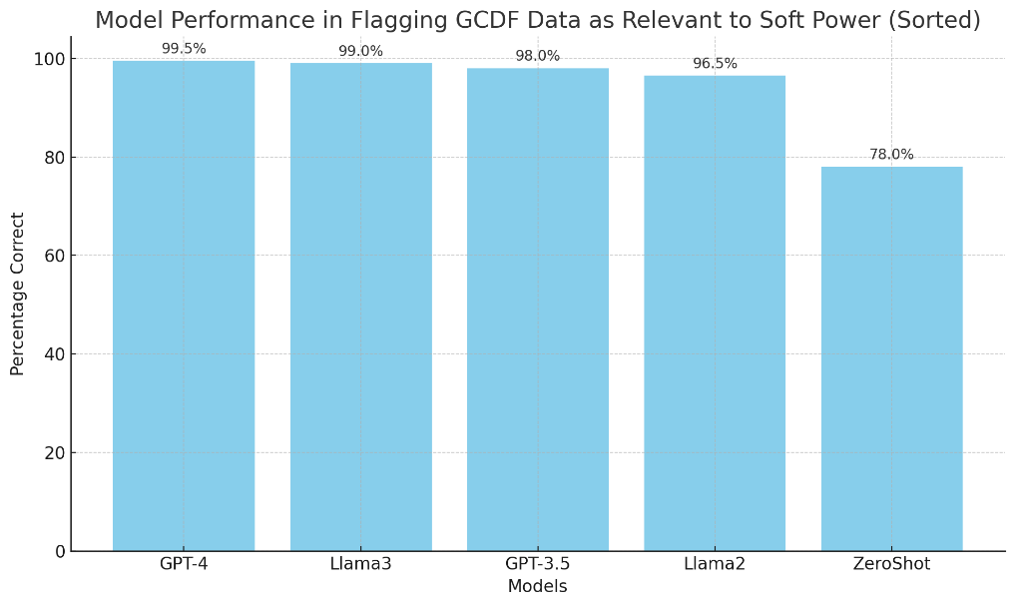

The high accuracy rates of Llama2, GPT-3.5, and especially GPT-4 suggest that advanced LLMs are highly effective at identifying text relevant to soft power interactions. However, with only positive samples, additional tests are necessary to measure its ability to distinguish positive and negative cases of soft power.

Categorization:
Using GCDF’s schema we tested the ability of the GAI model to interpreting a labelling schema in its prompt and apply it to a dataset without any prior training. Using the top 3 models, a prompt was designed to categorize a GCDP sample of 300 documents, broken into an even distribution of 20 documents per category, according to the W&M schema seen in the ‘Sector Name’ field.
Raw GAI Output: ```json{ "Salience": "TRUE","Salience_Justification": "The Chinese Government's pledge to forgive a portion of Zambia's debt for the TAZARA railway project is an example of soft power. It represents China's effort to strengthen bilateral relations and influence through economic means.","Category": "ACTION RELATING TO DEBT;TRANSPORT AND STORAGE", "Category_Justification": "The forgiveness of debt directly relates to financial obligations between two nations, affecting Zambia's economic situation and policy decisions. Additionally, the debt originated from a transportation infrastructure project, which is a strategic sector for development and influence.", "Initiating_Country": "China","Recipient_Country": "Zambia"}```
Post-Processed Preview: 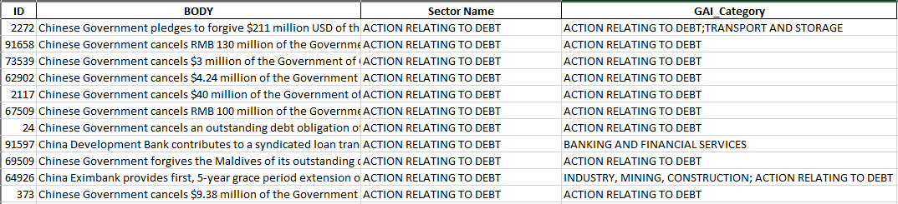

Results:
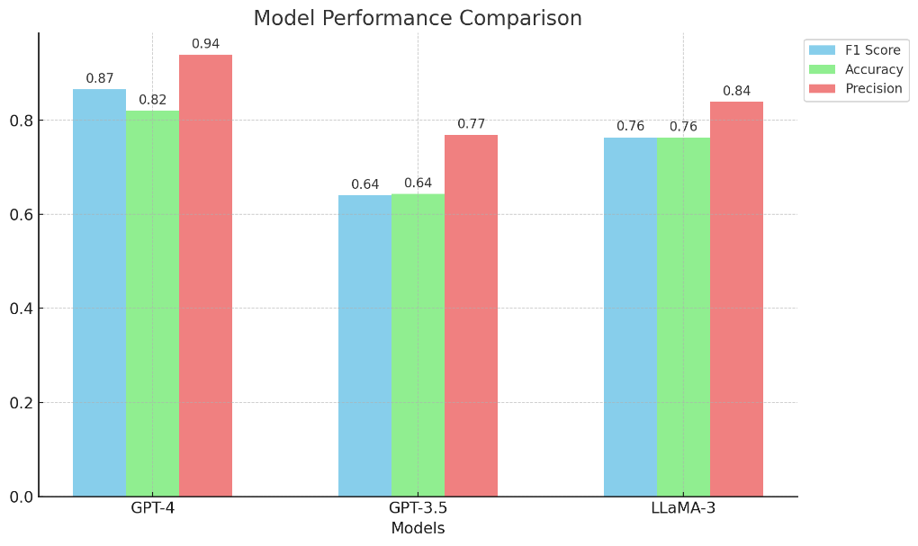
For this sample, GPT-4 with a .865 F1 score was very effective in correctly identifying the relevant categories, balancing both false positives and false negatives with a .94 precision score. While LLaMA-3 did not reach the high-performance level of GPT-4, it represents a middle ground with reasonably good precision and accuracy as an open-source alternative.
Extraction:
To test extraction, we prompted the GAI models to pull initiating and recipient countries based on the context in the GCDF description text. Since this was a China influence dataset, the test focused on the accuracy of the recipient countries.
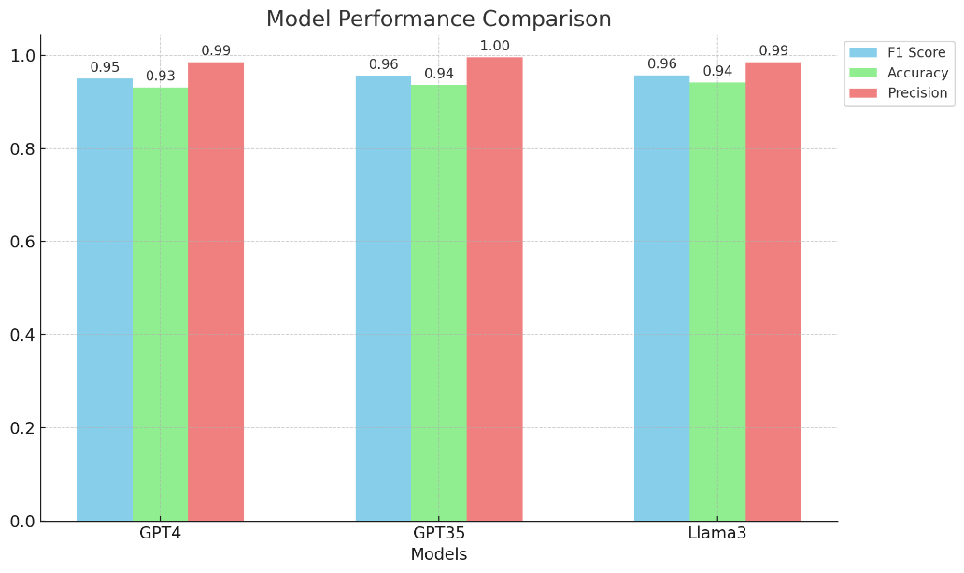
Results:

The LLM’s performance at country extractions across models was essentially perfect. Incorrect inputs were due to missing inputs in the GCDF or regional inputs rather than specific countries.

Through these tests and further experimentation on documents external to GCDF, it was immediately apparent that LLM’s could:
- Apply custom labeling schemas on demand.
- Apply a range of NLP tasks in a single prompt.
- Follow and apply detailed instructions accurately.
- Discern and correctly process vague concepts like Soft Power.
- Constrain outputs to formats that conform to post processing requirements.
Findings:
In regard to question 1 (can LLMs perform the required tasks), LLMs are more than capable of handling the extraction, classification, and summarization requirements of the Soft Power project in a single prompt. GPT 4 showed proficiency in not only categorizing texts under the broad umbrella of soft power but also in assigning them to specific sub-categories. It effectively identified additional detailed fields such as the amount of funding, the country exerting the influence, and the beneficiary country. These aspects of text classification. This capability to categorize data offers substantial adaptability for dynamically enriching information to align with multiple schemas. This had major implications for the project's trajectory, as it removed projected costs and risks associated with the development and maintenance of custom NLP models.
Note on prompt design: GPT4 is superior in its ability to keep its output consistent across long complicated prompts, whereas Llama models in particular struggled to apply constraints defined in the prompt, such as “DO NOT provide and explanation, preamble, or any information outside of the requested results.” Output format instructions also were applied inconsistently with Llama models, where GPT4 had little to no issues consistently outputting a variety of formatting schemas. Adjusting the prompt to incorporate json or dictionary structures in the output instructions such as “output the result in json, for example {“COUNTRY”: “France”}”, significantly improved the ability to utilize Lllama outputs with minor post processing requirements. Consistency in user provided examples presented to the model proved critical to its performance across a large dataset. A misspelling of a category field, missing something as small as a double quote, a missing ‘}’, appeared to give the models at the 3.5 turbo and Llama2 70b level leeway to vary its outputs in similarly small ways, which at scale would break post processing pipelines. GPT4 was more forgiving of small inconsistencies given to it in instructions, whereas 3.5 and Llama were very sensitive to syntactic inconsistencies.

Temperature:
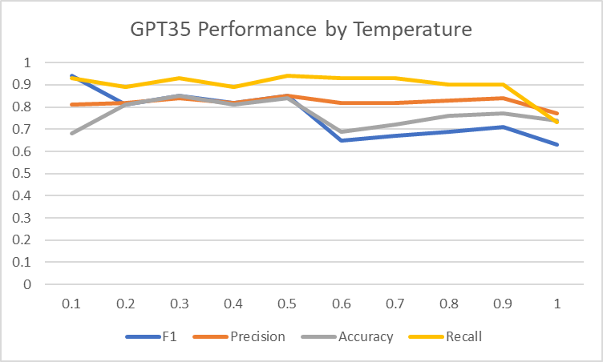
The effects of temperature were looked at on a random sample of the 100 NE_AUTO documents. These documents were also labelled using a hybrid GPT4/Human reviewed Salience column as a benchmark.

Limited Evaluation with Human Labelled data
Different prompt structures were tested, concise GPT35 prompts consistently return a high proportion of salient articles, likely indicating an overly generous interpretation of soft power. Providing a definition of soft power, and reiterating the task at each step in the prompt reduced the salience rate from 86%-56%. GPT4 in contrast, typically returned between 20% - 30% salience rates.
To get a ground truth data set with negative samples to evaluate model performance, we reached out to an external entity to review and apply labels to a sample set containing primarily NE_AUTO documents with GCDF documents mixed in. The Soft Power schema, along with annotation instructions were sent to the labelers. The GCDF samples provided confidence in the GAI’s ability to accurately identify positive samples and apply the Soft Power schema accurately.
Two labeling exercises were conducted to understand the model’s ability to differentiate between positive and negative soft power examples. In the first exercise, three labelers collaboratively labelled 100 documents. The data revealed a striking contrast between human and machine-generated salience labels. This discrepancy suggests that either human labelers applied a too narrow interpretation of 'soft power,' or the GAI and NLP models were overly generous.

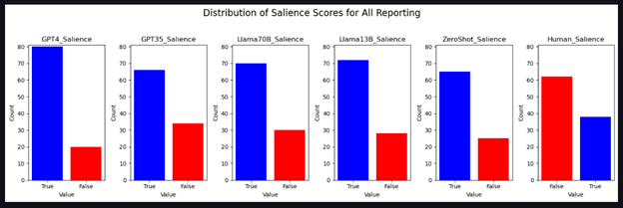
The above chart shows that GPT4 found 80 of the 100 documents relevant to soft power, while the human labeler found over 60 of the 100 samples irrelevant to soft power.

As an azimuth check on whether the GAI or human labeler, we incorporated GCDF samples in the review. The below chart shows both human and GAI models are in alignment with the GCDF interpretation. 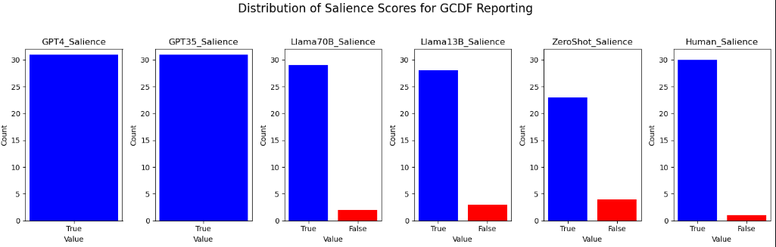
In samples from documents that contained bilateral and multilateral discussions in its text, you would expect a higher proportion of positive samples, here the LLM’s appear in better alignment.
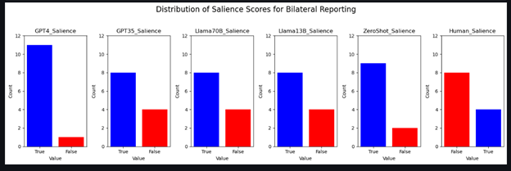
Naturally, there were caveats with these findings we would try to address in another round of labelling: the sample was small and meant for calibration, designed to identify mistakes and divergences in methodology by human labelers. We did not want to draw definitive conclusions without offering feedback and a chance for reassessment. Additionally. the human labels represent a collaborative effort from three labelers, not three independent analyses as we had planned, concealing various effects and potential biases that cannot be statistically normalized.
2nd Labeling Exericse
A second round was conducted on a separate set of 200 documents, consisting of NE_AUTO documents with some GCDF samples incorporated as an azimuth check. 3 labelers labelled the same documents independently in this iteration so we account for potential biases and outliers.
The same contrast was seen in the interpretation of what was and wasn’t a soft power event. Therefore, all LLM’s had a high False positive rate in comparison to human labels that skewed their performance metrics.
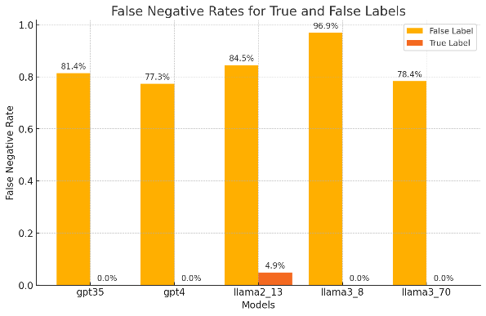
Salience Performance Against Human Labels: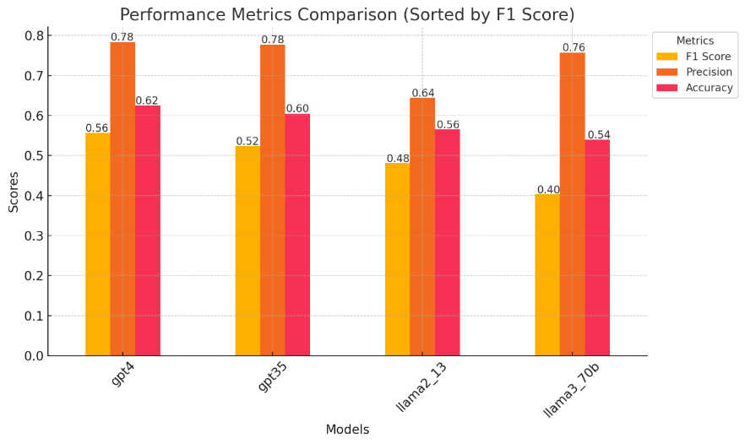
When filtering the results down to the documents there was agreement, the LLMs performance on categorizing the documents were very positive, with GPT-4 as the most effective model for document categorization, followed closely by Llama3_70B. These models are likely to be more accurate and consistent in matching human-labeled datasets. GPT-3.5 and Llama2_70B offer moderate performance, while Llama3_8B has the least accuracy and consistency.

Categorization Performance Against Human Labels:
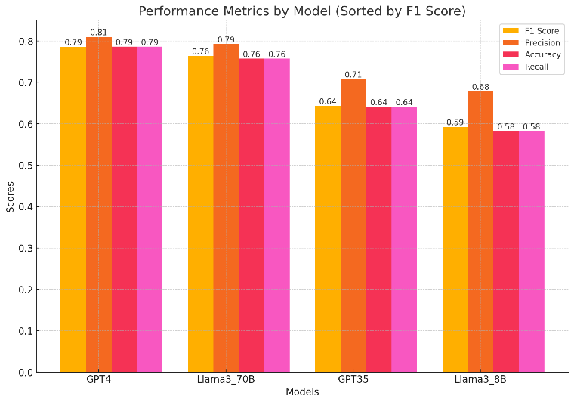
SubCategory Performance Against Human Labels: 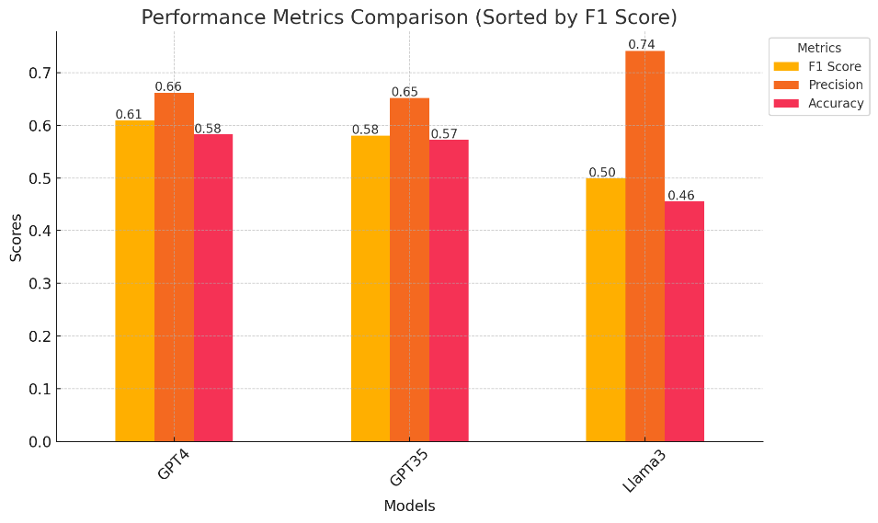

Evaluation Conclusions:
Initial findings were presented to analysts to show where there was disagreement between the model and the human labelers' interpretation of the text. When reviewing the disagreements, the analysts tended to agree with the model's interpretation, indicating that the human labelers' understanding of the topic in many cases was not in line with the analysts. Analysts agreeing more with the model suggests that the model might be capturing nuances human labelers miss.
This highlights a significant challenge in evaluating Generative AI (GAI) model performance on grey area topics like Soft Power. Soft Power is inherently subjective, and interpretations can vary widely, and it appears the human labelers interpretation did not align with what the analysts would have considered a relevant example of soft power.
False negative rates (FNR) again show the disparity in what falls outside of a soft power act, but also shows that the models aren’t missing positive salient samples of Soft Power identified by human labelers. Nearly all the models captured 100% of True samples identified by human labelers.
that perfectly aligns with the analysts' requirements, we face the challenge of continuously validating and refining the model's outputs. Utilizing reinforcement learning to validate GAI inputs as they come in can help improve alignment. Over time, retraining the model with feedback from analysts can better tune its inference capabilities. Open-source Large Language Models (LLMs) that allow for fine-tuning offer a promising path to achieve this alignment, enabling the model to better serve the mission's needs. Using reinforcement learning to validate inputs and fine-tuning the model based on analyst feedback can help align the model's inferences with the mission's needs. Open-source LLMs are particularly valuable in this regard, as they provide the flexibility needed for such fine-tuning. The use of open-source LLMs for customization and fine-tuning is a growing trend in industry. Open-source models provide the flexibility needed to adapt AI systems to unique requirements, similar to your strategy for aligning GAI with analysts' needs. Industries benefit from this adaptability to develop tailored solutions that better serve their specific use cases. The goal is to develop a model that can accurately and consistently interpret Soft Power actions in a way that aligns with analyst requirements. This involves a long-term commitment to refining the model through iterative feedback and retraining.

SME updated evaluation:
After iterative tests and feedback from the analysts, the extractive prompt was run against NE_AUTO holdings for a month, a representative sample of the extraction outputs and a random sample of salient and non-salient articles were put in front of SME’s to determine the level of agreement they had with the GAI’s inferences.
GPT4 Assigned Sub-Categories
The below charts illustrate the structured hierarchy of categories and subcategories that GPT-4 identified within the GCDF dataset. From a set of 1000 text samples, GPT-4 discerned more than 1200 distinct category-subcategory pairings. Notably, the additional layer provides a level of context which highlights the preponderance of China's COVID diplomacy efforts represented in the data. 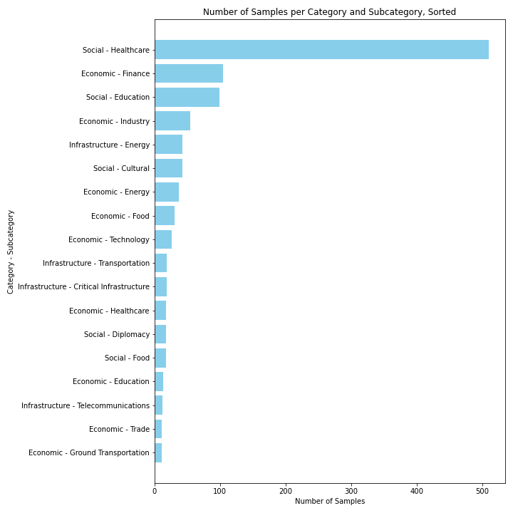
Human Evaluation:
The following evaluation framework seeks to assess the efficacy of Generative AI (GAI) in accurately recognizing and interpreting the concepts that encompass the use soft power in the context of international relations.
A set of articles will be allocated to human annotators for classification in accordance with the project's schema. This human-labeled data will be combined with labels generated by GAI and other NLP models to examine the agreement between the human and model-generated classifications in the hopes of being able to describe GAI's effectiveness relative to human performance and traditional NLP methodologies.
To maximize balance within the dataset, equal representation of each topic within the sample set will be achieved to the greatest extent feasible. The schema comprises four categories: Economic, Social, Utility, and Military. Aiming for a minimum dataset of 1,000 documents, the goal is to include 250 samples from each category. This equates to slightly more than 50 samples per topic, accompanied by 5-7 negative samples for each topic to ensure a comprehensive and balanced dataset. Each topic has several sub-topics, which require around a half dozen samples per sub-topic for balance purposes.
Labelling
To construct the human-labeled portion of the evaluation dataset, three annotators will be tasked with labeling 500 documents according to the below schema. Should the human labeling process yield more positive and negative samples than the above sample goals, the number of generated samples for the final evaluation will be adjusted accordingly. However, additional labeling efforts may be necessary if the dataset does not meet the 250-sample threshold or if there is an inadequate balance across topics and subtopics. 10% of the dataset will overlap across labelers to check consistency and remove outliers as necessary.
Upon achieving a comprehensive set of human-labeled samples, this data will be integrated with generated samples from GPT-3.5, GPT-4, and traditional NLP techniques to construct a robust evaluation dataset.
Evaluation
The evaluation process will involve three to five independent evaluators, distinct from the labelers, tasked with scoring the labeled dataset without knowledge of the labels' origins. They will assess each sample based on its conformity with the applied labels, utilizing a three-point scale: disagree, somewhat agree, and agree. Each label field will be scored individually. To standardize scores and mitigate bias, 10% of the evaluation set will be shared among all evaluators, facilitating a comparative analysis of the quantity and quality of generative and traditional NLP approaches against human performance.

OSE’s Workforce Enablement Group (WEG)’s Oilers team provided excellent templates and best practices on prompting LLM’s like ChatGPT for specified NLP taskings like entity extraction, classification, and summarization.
The GAI model and GCDF had different country naming and spelling conventions. In cases where the GAI extracted the correct country under a different naming convention, we counted those extractions as correct. For example, GCDF: Cote d'Ivoire vs GAI: Cote D'Ivoire or GCDF: "Democratic People's Republic of Korea" vs GAI: “North Korea.”
GPT4 was ran on multiple ATOM queries including a bilateral query that searched for terms synonymous with soft power and international relations, a country focused query that incorporated two or more countries in the body text, and a random query that was used to pull a random sample and generate likely false instances.
Reinforcement learning (RL) provides a framework for the model to improve iteratively. By incorporating feedback mechanisms where the model's outputs are evaluated and corrected, the model can learn to better discern and classify soft power events. Over time, the model's exposure to a diverse set of data—beyond the initial William & Mary dataset—would enable it to refine its interpretations and adapt to the subtle nuances of soft power as they pertain to various geopolitical contexts. The iterative nature of RL would also help address the variability and subjectivity inherent in labeling soft power events. As the model encounters a broader range of examples, it can develop a more sophisticated understanding of what constitutes soft power, aligning its interpretations more closely with Agency information requirements.
Salience Prompt: ‘’’You are an international relations expert on the use of Soft Power influence from one country towards another. Please execute the following: 1. Assess whether the given text is an example of the use of soft power between two governments to influence another state's perception of them through attraction, persuasion, or positive perception. 2. If it does, return {"Salience": "TRUE"}, if it doesn't return {"Salience": "FALSE"}. Output the result in json, for example {"Salience": "TRUE"} or {"Salience": "FALSE"}. IMPORTANT: ONLY output the json result.’’’
Categorization and Extraction Prompt: """You are an expert in tracking and identifying inter-country 'soft power' engagements, where one country through economic, social, cultural, or political means, fosters influence over another country. Please execute the following steps: 1. Determine if the provided text as a whole is an example of soft power or influence activities of one country towards another. 2. If it is, in 200 words or less, explain why the text was determined to be either an example of soft power or not an example of soft power. 3. If the text is an example of soft power, identify the nature of the activity and output one or more of the following categories, if more than one topic is relevant, separate them by semicolons. 'EDUCATION', 'GENERAL BUDGET SUPPORT', 'HEALTH', 'INDUSTRY, MINING, CONSTRUCTION', 'TRADE POLICIES AND REGULATIONS', 'ENERGY', 'EMERGENCY RESPONSE', 'WATER SUPPLY AND SANITATION', 'TRANSPORT AND STORAGE', 'DEVELOPMENTAL FOOD AID/FOOD SECURITY ASSISTANCE', 'AGRICULTURE, FORESTRY, FISHING', 'COMMUNICATIONS', 'ACTION RELATING TO DEBT', 'BANKING AND FINANCIAL SERVICES', 'GOVERNMENT AND CIVIL SOCIETY' 4. In 200 words or less, explain why the specific category or categories was selected. 5. Determine the country initiating the softpower exchange from the provided text. If more than one initiating country is identified, separate them with semicolons. 6. Determine the recipient country of the softpower exchange from the provided text. If more than one recipient country is identified, separate them with semicolons. 7. Output the result in json, for example {"Salience": "TRUE", "Salience_Justification": "X country is attempting to influence Y county's decision making","Category": "DEVELOPMENTAL FOOD AID/FOOD SECURITY ASSISTANCE", "Category_Justification": "X country"s donation of food to Y country during the famine is an example of soft power", "Initiating_Country": "China", "Recipient_Country": "Iraq"}, {"Salience": "FALSE", "Salience_Justification": "The text does not present an example of soft power", "Category": "N/A", "Category_Justification": "N/A", "Subcategory": "N/A", "Initiating_Country": "N/A", "Recipient_Country": "N/A"}."""
Costs of labelers and scale of labelling requirements per 1000 documents. - Time: 1000 labelled documents * 20min per doc/60min = 330hrs (2 months) - Labelling Cost: 250 * $25/1hr = $8,250 - Calibration Cost: (100 docs * (20minutes per doc/60min) * $25/hr = $825 - Quality Control: (1000 docs * 20docs per hr) * $25/hr = $1250 - Total: $8,250 + $825 + $1,250 = $10,325 per 1000 documents Developer costs - spaCy’s guideline for training a custom NER model suggests at least 4000 annotated samples. - Assuming an ideal that 80% of documents contain at least one of the categories, to achieve 4000 samples we would need a minimum of 5000 documents reviewed. (10,325 *5) = $51,625 - Computation for testing and evaluation: 5-10K - and DS Costs: (75/hr * (40hr *24wk) = (72K * # of developers and data scientists) - Specialized labelers, low sample rates across documents, and the number of developers can significantly increase costs for preparing training data. For example, a low prevalence of samples per doc, say 30%, would require more than double the number of documents to be reviewed, pushing costs above 100K for labelling alone. Overall Costs (Estimated) - $150,000 – $450,000 This estimate doesn’t account for costs of software such as IDE’s, licensing fees, data acquisition, and infrastructural costs. Alternatively, offices often deploy pretrained NLP models, and attempt to programmatically realign their outputs to fit mission requirements. This is the most common approach used by offices willing to invest in data science talent but don’t want to the costs/risks associated with model development. Those savings could be transferred to testing various LLM options (open source versus subscription based models) and running exploratory LLM runs on larger datasets.
Risks involved with building a custom NER model include prolonged development time, high initial investment, and uncertain accuracy. The quality of training data is crucial, and errors in annotation or inconsistent data can severely impact model performance. Additionally, custom models require continuous maintenance, including retraining with new data and updating for emerging entities, leading to ongoing operational costs. These models also face challenges in scalability and flexibility, as they are typically tailored to specific tasks and may struggle to adapt to new requirements without significant re-engineering.
Labeling instructions For both labelling and evaluation efforts, a calibration session will be conducted to ensure consistency in practices, identify any task ambiguities through labeler and evaluator feedback, and aid in refining our evaluation criteria for more accurate outcomes. Estimated Level of Effort Labelling (Calibration) Description Apply Project, Category, Sub-Category, Initiating Country, Receiving Country, and Funding labels with a short 5-10 words description. Number of Documents 100 Number of Labelers 3 Average article Length 498 words Longest Article 2938 words Shortest Article 101 words Avg Time Per Article 10 minutes Total LOE 16 hrs LOE per Labeler 16 hrs Labelling Description Apply Project, Category, Sub-Category, Initiating Country, Receiving Country, and Funding labels with a short 5-10 words description. Number of Documents 500 Number of Labelers 3 Average article Length 498 words Longest Article 2938 words Shortest Article 101 words Avg Time Per Article 10 minutes Total LOE 83 hrs LOE per Labeler 28 hrs Evaluation (Calibration) Description Score Labelling accuracy according to a 3-point scale Number of Documents 100 Number of Evaluators 3-5 (distinct from labellers) Average article Length 498 words Longest Article 2938 words Shortest Article 101 words Avg Time Per Article 5 minutes Total LOE 8 hrs LOE per Evaluator 8 hrs Full Evaluation Description Apply Project, Category, Sub-Category, Initiating Country, Receiving Country, and Funding labels with a short 5-10 words description. Number of Documents 1000 Average article Length 498 words Longest Article 2938 words Shortest Article 101 words Avg Time Per Article 5 minutes LOE 83 hrs LOE per Evaluator 16-28 hrs Evaluation Schema Number of Evaluators 3-5 Criteria Agree, Somewhat Agree, Disagree Agree The evaluator agrees with the label; the label is applied correctly according to the schema. Somewhat Agree The evaluator finds the label plausible; the label is broad/generous application of the schema. Disagree The evaluator disagrees with the label; the label is misleading or does not align to the schema. Labelling Schema Number of Labelers 3 Label 1: Relevance TRUE/FALSE is the document relevant to SoftPower Label 2: Summary If FALSE, leave remaining fields blank and continue. If TRUE, write a short description (10-15 words) describing the activity and complete the remaining label fields. Label 3: Project Identify specific projects, conferences, or initiative names. Label 4: Initiating Country Identify which country is the recipient of the activity Label 5: Receiving Country Identify which country is the recipient of the activity Label 6: Location Identify the geographic location of the activity or commitment Label 7: Funding If applicable, identify the monetary commitment of the activity Label 8: Category Identify the nature of the activity and apply one or more of the following categories: Economic, Social, Utility, Military. Label 9: Sub-Category Identify a subcategory which the activity falls under using the following schema. Labelling Schema: 1. Assess if the article is relevant to or discusses Soft Power activities, commitments, or interactions between nation states. 2. Write a short title describing (100 words or less) of the activity. 3. Identify specific projects, conferences, or initiative names, for example, "Maputo Central Hospital," "National Theater Renovation Project," or "Tengchong-Myitkyina Road Construction Project;Opium Alternative Planting Project." If more than one project is identified, separate them with semicolons. 4. Identify which country initiated the activity, and output, for example, "China," "Egypt," or "China; Egypt." If more than one country is identified, separate them with semicolons. 5. Identify which country is the recipient of the activity, and output, for example, "China," "Egypt," or "China; Egypt." If more than one country is identified, separate them with semicolons. 6. Identify and output the geographic location of the activity or commitment, e.g., "Cairo, Egypt." 7. If applicable, Identify and output the monetary commitment of the activity of commitment, "$100,000,000." 8. Identify the nature of the activity and output one or more of the following categories, if more than one topic - "Economic": characterized by the predominance of a particular money-making activity. - "Social": Characterized by influence on social activity and societal relationships in daily life. - Utility": Characterized by the construction of distribution lines and related building and structures that are an integral part of those systems. - Military": Characterized by the strategic use of a nation's military capabilities and assets to achieve influence and foster relationships. 9. Identify a subcategory which the activity falls under using the following schema. If the nature of the activity is "Economic", determine which of the following economic sub-categories the activity falls under: - Trade: Characterized by advantages or disadvantages in trade arrangements or change in trade agreements that could be used as leverage. - Food: Characterized by the delivery, processing, or development of food for humans. - Finance: Related to banking, lending, and other financial relationships or transactions - Technology: Characterized by innovative exchanages, sharing of advanced technology, or cooperative research and development efforts. - Air Transportation: The movement of freight, development projects, and services, related to the operation of terminal facilities and airports - Ground Transportation: The movement of goods, development projects, and services related to railroad, bridges, tunnels, and highways. - Sea Transportation: The movement of freight, development projects, and services related to maritime activies and waterway navigation. - Tourism: Services and commercial activities including lodging, restraunts, entertainment, sports, and other means of providing for persons temporarily staying in the host nation. - Industrial: Supporting large scale production through the construction of factories and manufacturing supply chains, as well as the provision of capabilities designed to produce goods at scale. - Raw Materials: Projects related to the extraction, refinement, or distribution of raw materials, to include oil, natural gas, earth metals, and other raw materials. - If the economic activity doesn't fit any of the above categories, input "Other-" with a one word label of the activity of your choosing. If the nature of the activity is "Social", determine which of the following social sub-categories the activity falls under: - Cultural: Projects related to recreation and promotion of cultural activities, inlcuding artists and art galleries, as well as culturally oriented organizations. - Diplomacy: Establishment of diplomatic relations, initiatives, or aggreements targetting the host nations decision making or perception. - Education: Construction of schools and other educational institutions of high learning. This includes teacher development and recruitment. Shaping educational policies and influencing student body perceptions and opinions. Additionally this can include the establishment of educational organizations and clubs on campuses. - Healthcare: Providing services or buildings related to treating, diagnosing, and preventing human diseases and sicknesses. This includes health related services at hospitals, psychiatric and substance abuse facilities, nursing homes, asylums, rehabilitation centers, health clinics, individual practitioners. - Housing: Projects providing access to housing, construction of housing, and residential development projects. - Media: Engagment in host nation media and news outlets in audio, visual, or textual formats. - Politics: Interference or influence of host nation political processes to include elections, campaign finances, or preference of individual political candidates. - Religious: Providing religious buildings, faith services, or other religious functions to host nation populace. - If the social activity doesn't fit any of the above categories, return "Other-"with a one word label of the activity. If the nature of the activity is "Utility", determine which of the following utility subcategories the activity falls under: - Energy: The production or delivery of electrical power, these may be generators, power plants, power lines, power stations and substations, or similar energy related structures. - Water: The production or delivery of water for human use. This includes the construction of water related infrastructure such as pipes, desalinization, and sanitation services. - Waste: Projects and services related to sewage removal and its associated infrastructure and treatment services. - Communications: Projects related to electronic communications, such as antennas, modems, laser optics, radios, switches, telecommunications and cell phone networks, internet infrastructure and cell towers and other electronic communications. - If the utility activity doesn't fit any of the above examples, return "Other-" with a one word label of the activity. If the nature of the activity is "Military", determine with of the following military sub-categories the activity falls under: - Sales: Agreements or announcements to sell weapons - Joint Exercises: Joining bilateral military exercises with the host nation - Training: Providing institutions or resources for military training purposes, to include hosting officers in military education institutions or sending officers to host nation military institutions. - Conferences: Hosting or attending forums of key military leaders and high ranking officers. - If the military activity doesn't fit any of these, return "Other-" with a one word label of the activity.

